**Pizza Sales SQL Queries**

**KPI’s**

1. **Total Revenue**

select sum(total_price) as Total_Revenue from pizza_sales

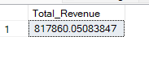

1. **Average Order Value**

select sum(total_price) / count(distinct order_id) as Avg_Order_value from pizza_sales



1. **Total Pizza Sold**

select sum(quantity) as Total_Pizza_Sold from pizza_sales



1. **Total Orders**

select COUNT(distinct order_id) as Total_Orders from pizza_sales



1. **Average Pizzas per Order**

select CAST(CAST(SUM(quantity) as decimal(10,2)) / CAST(COUNT(distinct order_id) as decimal(10,2)) as decimal(10,2)) as Avg_Pizzas_per_Order from pizza_sales



**FOR CHARTS**

1. **Daily Trend for total orders**

SELECT DATENAME(DW, order_date) as order_day, COUNT(DISTINCT order_id) as Total_orders from pizza_sales

GROUP BY DATENAME(DW, order_date)

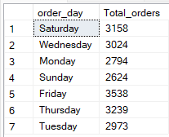

1. **Hourly Trend for total orders**

SELECT DATEPART(HOUR, order_time) as order_hours, COUNT(DISTINCT order_id) as Total_orders from pizza_sales

GROUP BY DATEPART(HOUR, order_time)

ORDER BY DATEPART(HOUR, order_time)

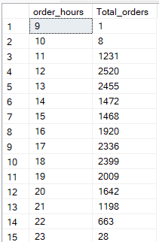

1. **Percentage of sales by pizza category**

SELECT pizza_category, SUM(total_price) as Total_Sales, SUM(total_price) * 100 / (SELECT SUM(total_price) from pizza_sales) as Per_Total_Sales from pizza_sales

GROUP BY pizza_category

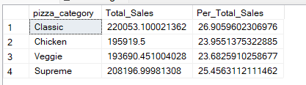

1. **Percentage of sales by pizza size**

SELECT pizza_size, CAST(SUM(total_price) as decimal(10,2)) as Total_Sales, CAST(SUM(total_price) * 100 / (SELECT SUM(total_price) from pizza_sales WHERE DATEPART(quarter, order_date) = 1) as decimal(10,2)) as Per_Total_Sales from pizza_sales

WHERE DATEPART(quarter, order_date) = 1

GROUP BY pizza_size

ORDER BY Per_Total_Sales DESC

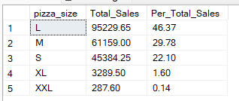

1. **Total Pizzas sold by pizza category**

SELECT pizza_category, sum(quantity) as Total_Pizzas_Sold FROM pizza_sales

GROUP BY pizza_category

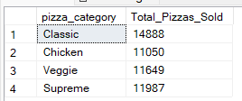

1. **Top 5 best sellers by Total Pizzas sold**

SELECT TOP 5 pizza_name, sum(quantity) as Total_Pizzas_Sold FROM pizza_sales

GROUP BY pizza_name

ORDER BY sum(quantity) DESC

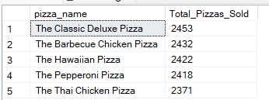

1. **Bottom 5 worst sellers by Total Pizzas sold**

SELECT TOP 5 pizza_name, sum(quantity) as Total_Pizzas_Sold FROM pizza_sales

WHERE MONTH(order_date ) = 8

GROUP BY pizza_name

ORDER BY sum(quantity) ASC

